**ROLL NO:737819ECR093**

**CIRCUIT DIAGRAM IN TINKERCAD:**

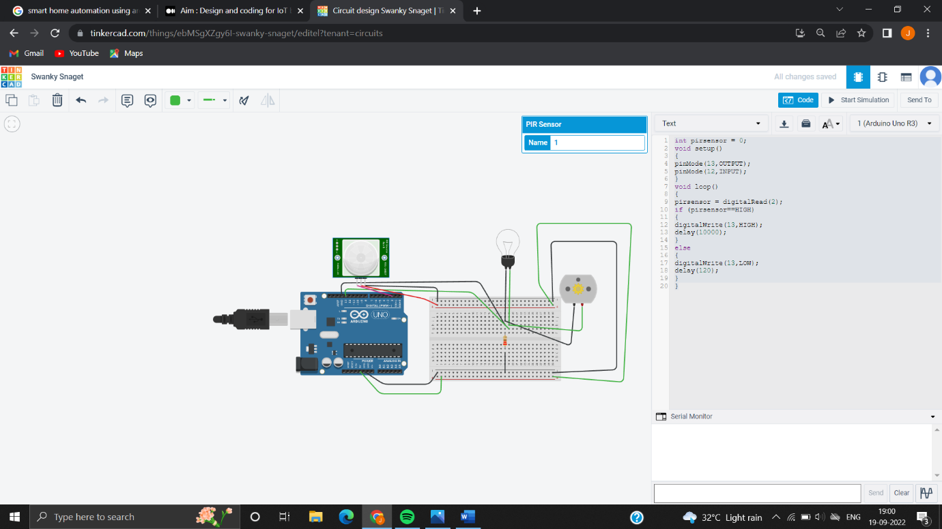

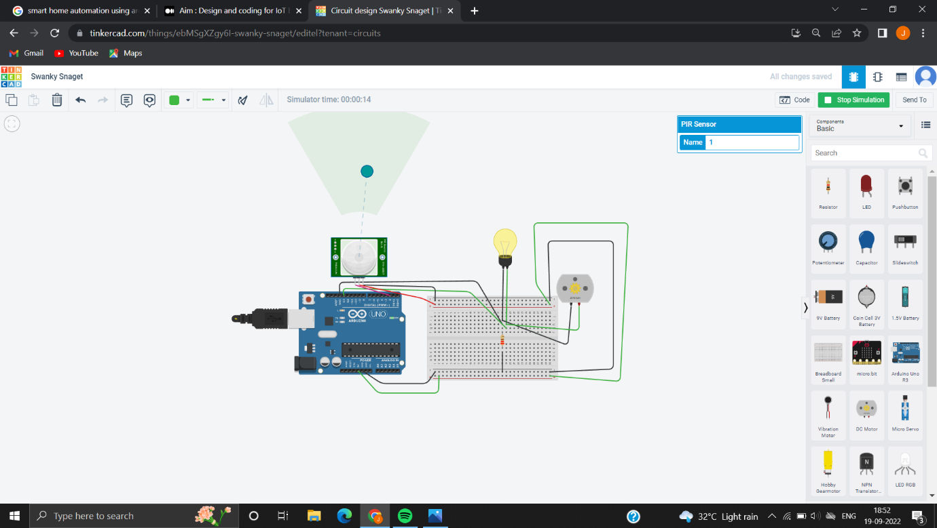

THE MAIN OBJECTIVES OF THIS PROJECT ARE GIVEN BELOW:

1. Automatically turn ON/OFf the lights when a person enters or leaves the room.
2. Automatically turn ON/OFf the fan when a person enters or leaves the room.

**CODE:**

int pirsensor = 0;

void setup()

{

pinMode(13,OUTPUT);

pinMode(12,INPUT);

}

void loop()

{

pirsensor = digitalRead(2);

if (pirsensor==HIGH)

{

digitalWrite(13,HIGH);

delay(10000);

}

else

{

digitalWrite(13,LOW);

delay(120);

}

}